“Life in all its fullness” John 10:10

KISIIZI HOSPITAL ELECTIVE STUDENT PACKAGE
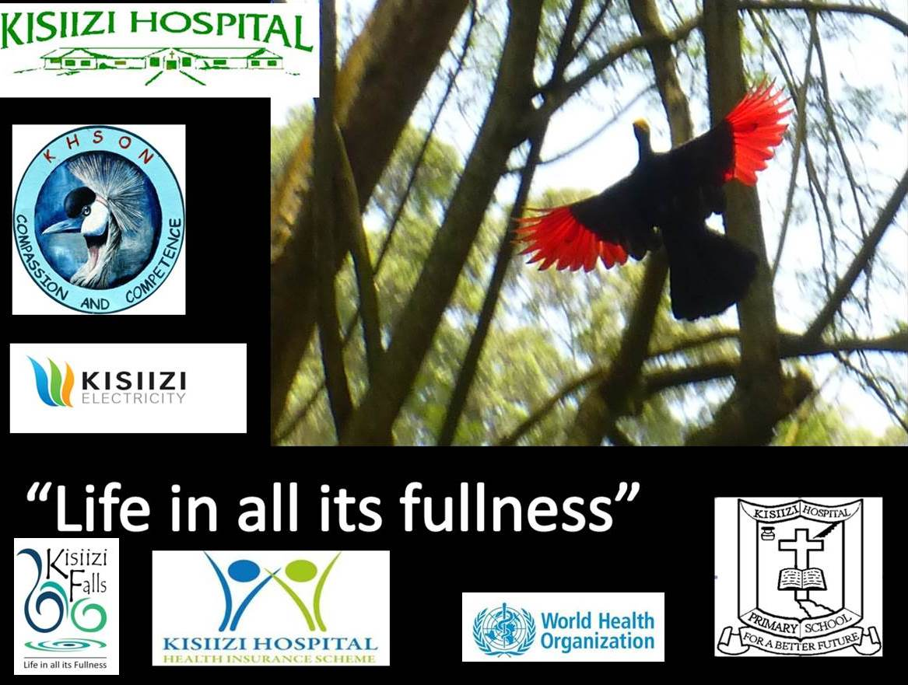
Kisiizi is a wonderful place for a medical, nursing or midwifery elective and has attracted visitors from all over the world. There is a wide range of clinical services serving a very poor rural resource-poor community.
In addition Kisiizi has the oldest Community Health Insurance Scheme in Uganda with over 40,000 beneficiaries in 5 Districts in 207 community groups up to 60km from Kisiizi.
Unusually Kisiizi also provides in-patient psychiatric services and a community mental health outreach service which is rare in remote rural settings.
Kisiizi was the only hospital in Uganda to be part of the first wave of the World Health Organization African Partnerships for Patient Safety and continues strong links with WHO.

Do look at www.kisiizihospital.org.ug for more details about the hospital.

In addition Kisiizi runs the Kisiizi Falls tourism site whose proceeds support the Good Samaritan Fund which helps the poorest and most needy patients.
See www.kisiizifalls.com for details and TripAdvisor reviews on https://www.tripadvisor.com/Attraction_Review-g1372043-d13339312-Reviews-Kisiizi_Falls-Rukungiri_Western_Region.html

Kisiizi Electives enquiries: khelectives@gmail.com
Kisiizi Falls email: kisiizifalls@gmail.com
Electives Package:
Elective students will be allocated rooms in the Guest House. Occasionally students are asked to move rooms during their stay in Kisiizi but we try to minimise this. You may be asked to share a room.

The package includes
- Accommodation and Full board including breakfast, lunch and dinner in the Guest House which serves a range of food including western and local dishes
- Morning tea/bananas in the hospital staff room during the week.
- Hot drinks are available free of charge as required
- Wifi internet access
- Free access to Kisiizi Falls tourism area (there is a charge for the SkyTrail zip-line, mountain bike hire and canoe hire)
- Laundry facilities
- Priority access to healthcare if required (healthcare costs are subsidised)
- Provision of clinical sundries e.g. disposable gloves, operating theatre clothes, masks etc.
- Access to join community health trips e.g. antenatal & child immunisation (5 times a month), mental health clinics (2 times a month) etc (subject to availability of space in the vehicle).
- Access to the Kisiizi Hospital Continuing Professional Development teaching and audit sessions
- Free access to keep fit classes, sports including badminton, netball, volley ball
- Provision of an official stamped and signed testimonial on headed hospital paper to record your attendance

The cost of the package (as at February 2018) is 120 pounds sterling per week or equivalent. In addition we ask for a one-off contribution of 120 pounds sterling for the Good Samaritan Fund to help Kisiizi in its policy of never turning patients away and supporting the poorest members of our community where needed. The GSF subsidises mental health care, insulin for diabetics and pays for formula milk for pre-term infants whose mothers have insufficient breast milk.

Please Note: Refunds will not be given if one chooses to cut short their stay.
We request payment by one month prior to your agreed arrival date.
For UK visitors, please pay into the Kisiizi Hospital National Westminster bank account
Address 20 High Street, Tring, Hertfordshire. HP23 5AH Account Number: 06513123, Sort Code: 55-70-10 IBAN Number: GB38NWBK55701006513123 BIC: NWBKGB2131G

For non-UK visitors please use Church of Uganda Kisiizi Hospital Barclays Bank –
Barclays Bank: Branch: KABALE Address: Plot 190, Kabale Road, Kabale, Uganda
Swift code: BARCUGKX Sort Code 01-32-61 Account Name: C.O.U. Kisiizi Hospital
Account Number: 6003717303 (this will do as an IBAN number too)
Please include a clear reference with the payment so we recognise who it is from and send an email telling us which account you have paid into and the amount and date. Thank you.
Appendix 1: KISIIZI FALLS GUEST HOUSE
includes free access to the Kisiizi Falls tourism site. (see www.kisiizifalls.com)

The beautiful Kisiizi Falls are enhanced by viewing from the new suspension bridge while the history of transformation from a place of despair to one of hope is dramatically portrayed in the magnificent monument. For the adventurous the 3-stage SkyTrail zipline runs high above the Falls. A Visitors’ Centre explains the fascinating Kisiizi story.

Accommodation includes:
The two-bedroomed self-contained Round Houses, located overlooking the meadow to the Falls and Monument, offer a peaceful place to rest and enjoy the beautiful variety of birds. Guests may choose to self cater using the small kitchens or eat in the main Guest House.
Round House 1 sleeps up to 4 in two twin or a double and twin configuration. Round House 2 sleeps up to 3 in a double and single room.

The Main Guest House has two double/twin and 4 single rooms with shared bathrooms and toilets. Food is a mixture of local and western meals. Free hot drinks are included.

The Guest House Annexe has 2 single, one triple and one large double room with shared bathroom.

Electricity: Kisiizi Hospital generates hydro-electricity on a mini-grid serving the community up to 7km from Kisiizi.
Hot water: Provided
Internet: Wifi available to an Airtel connection
Phone: Mr. Philip Twesigye, In-charge Guest House, 0759 512764
Payment: Cash – Uganda shillings (US dollars, Euros, Pounds Sterling may be acceptable by arrangement)

* Entry to Kisiizi Falls tourism site and hot drinks included
Packed lunches and snacks available on request

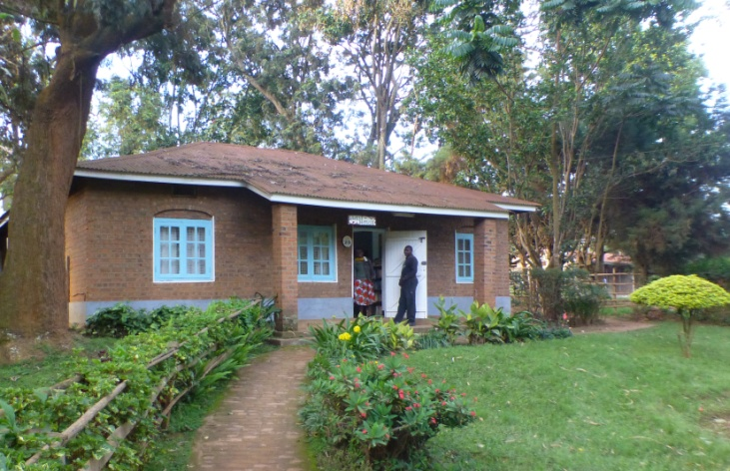
Kisiizi Falls Guest House
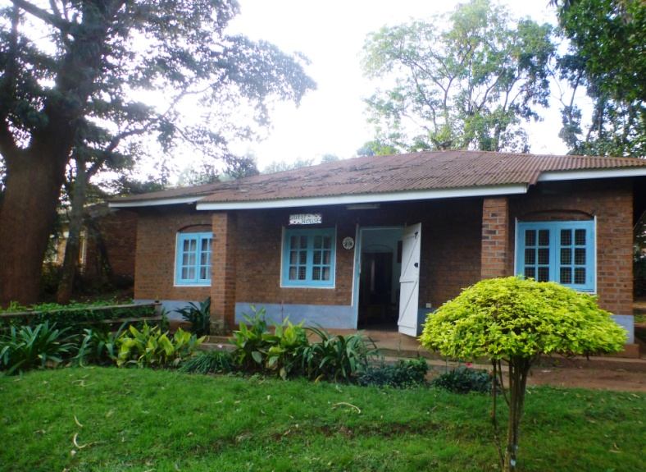

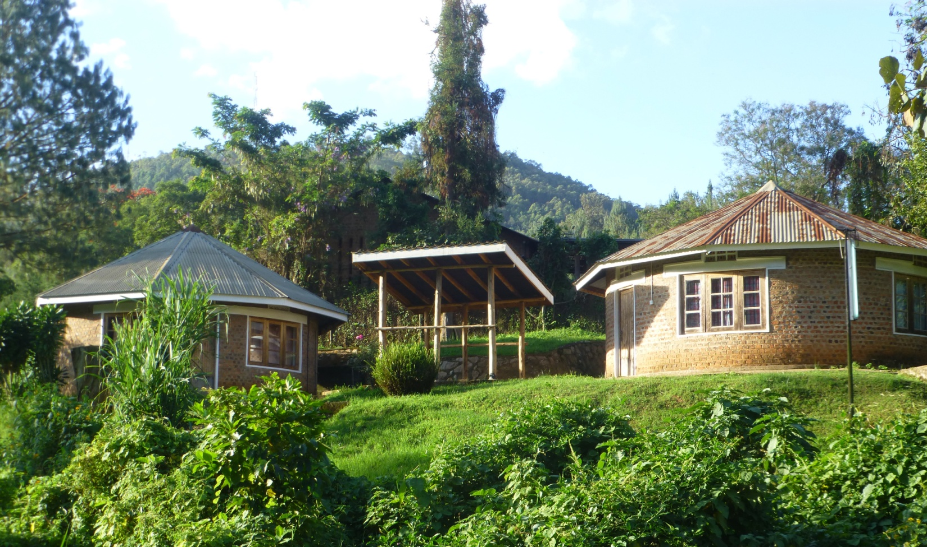
The Kisiizi Falls Round Houses
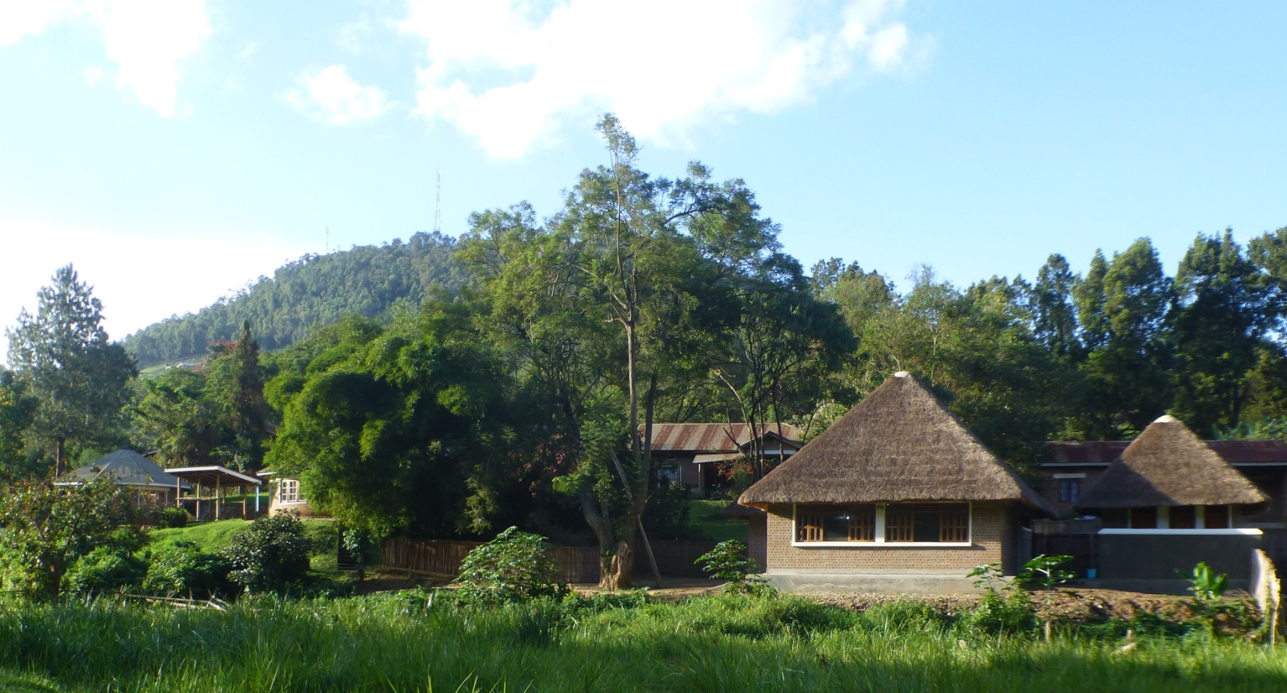 The Kisiizi Falls Round Houses seen on the left in relation to the Visitors’ Centre on the right

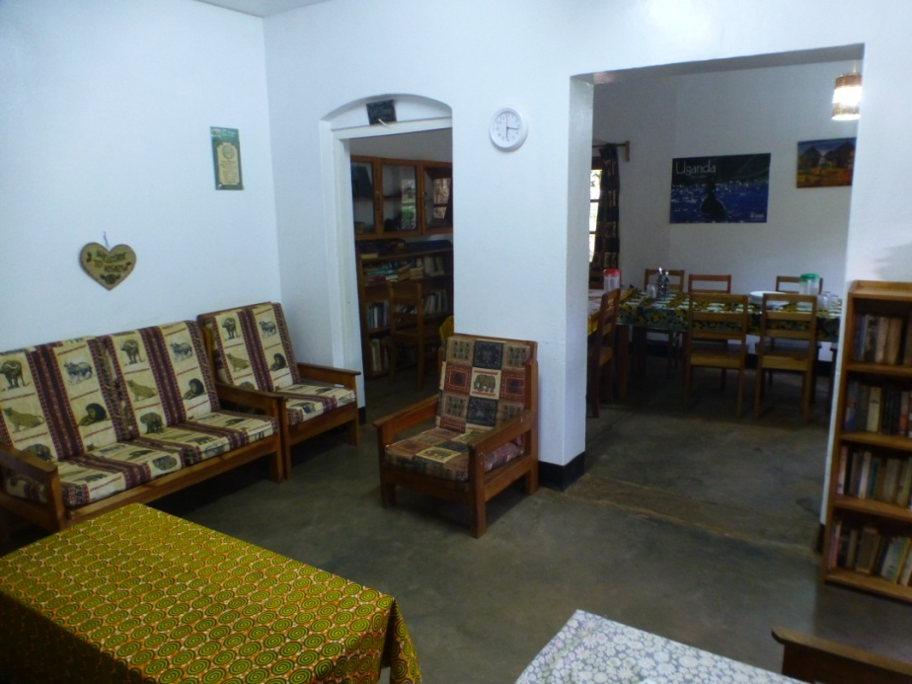

Guest House dining room / lounge

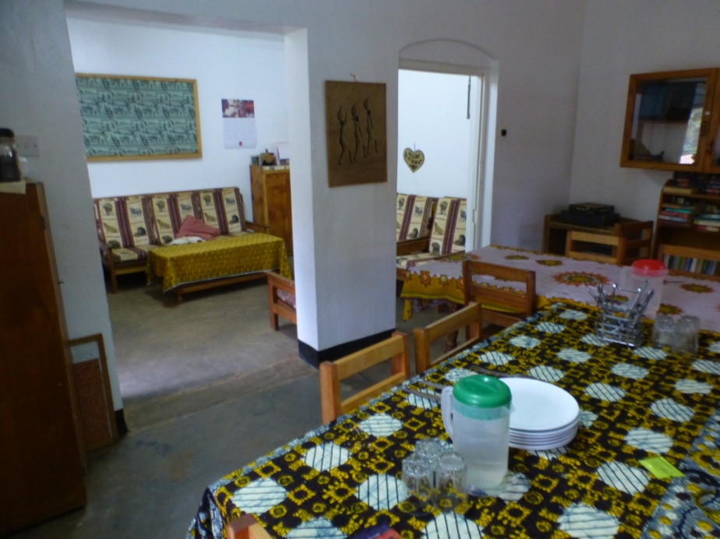

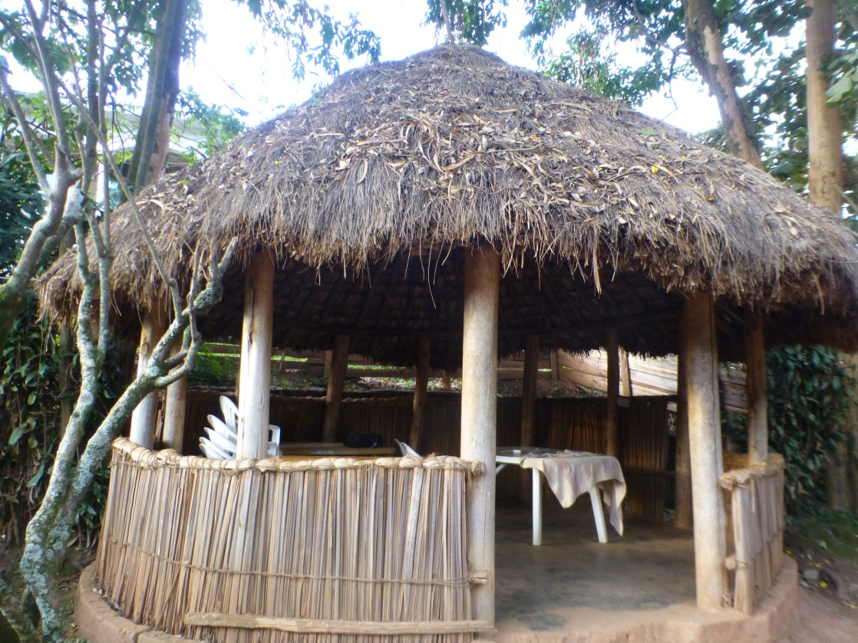

Banda behind main guest house
The Guest House annexe is in this building near the entrance to the Kisiizi Falls tourism site

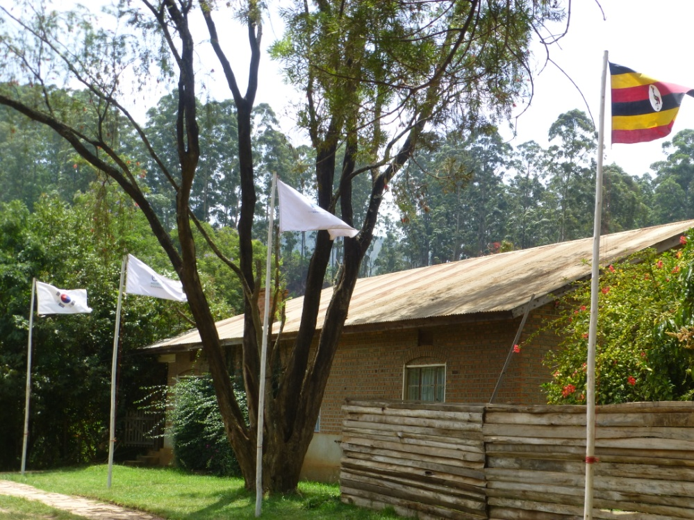

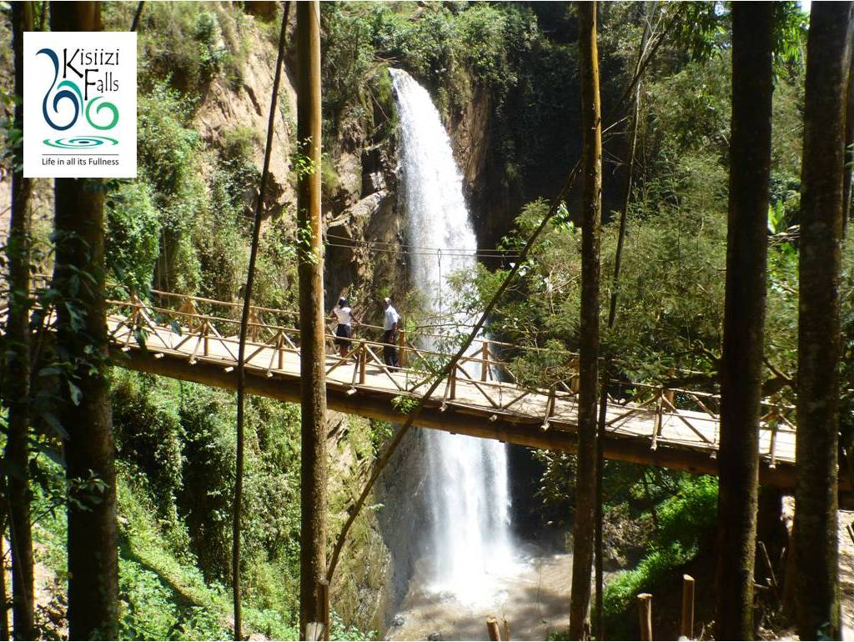
Appendix 2

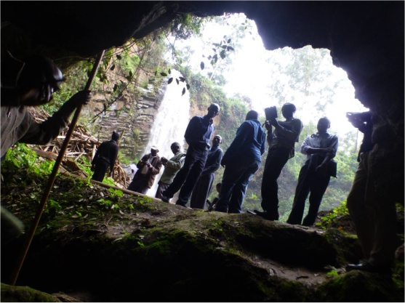
View beautiful Kisiizi Falls from the Suspension Bridge and small cave,
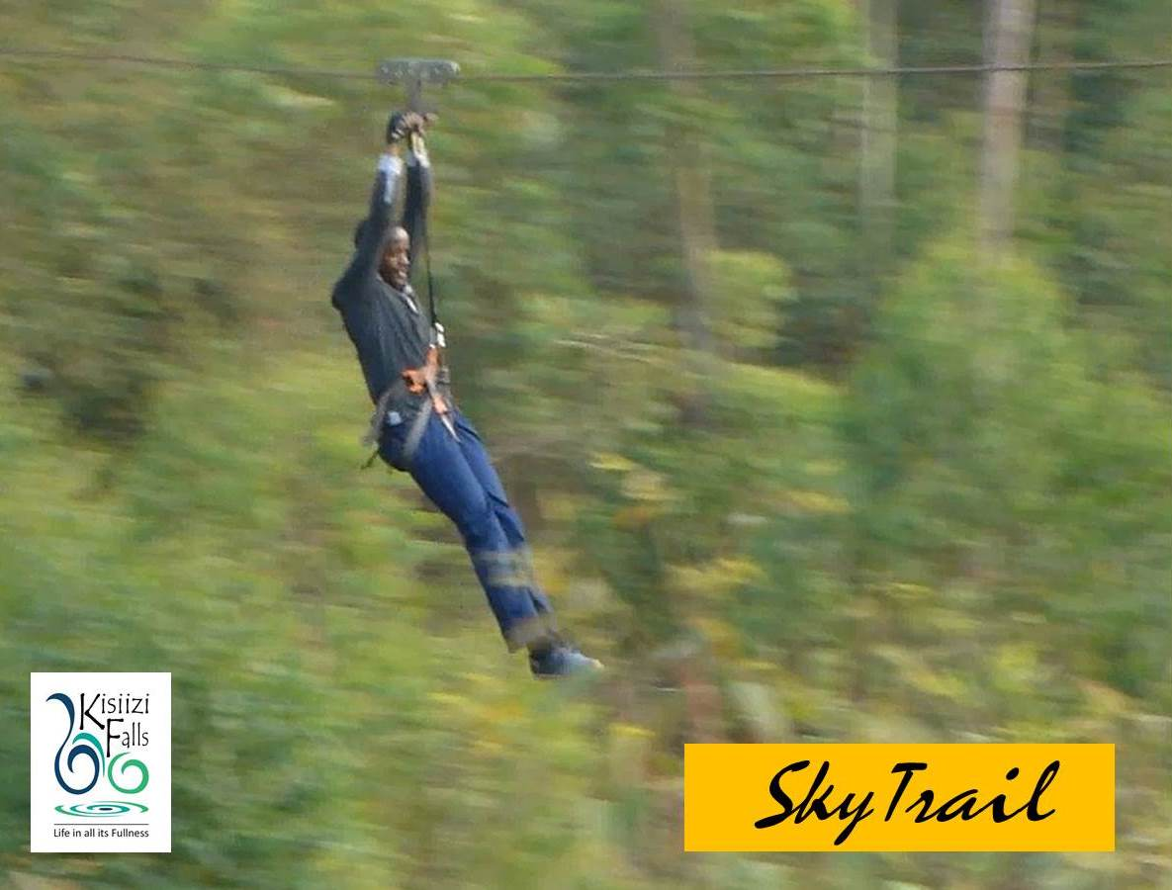
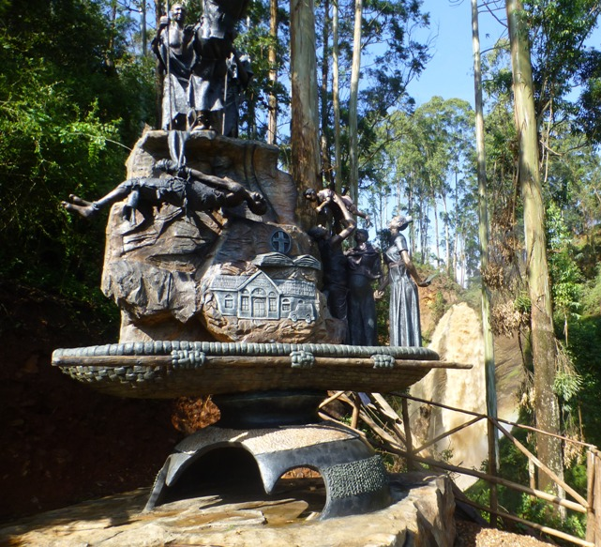
Visit the unique dramatic Monument, ride the high-altitude high-adrenaline SkyTrail 3-stage zip-line.

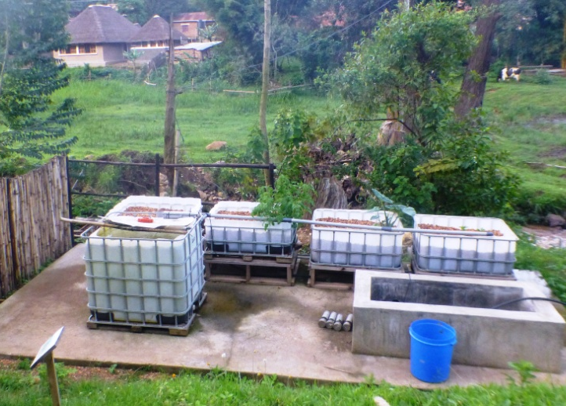
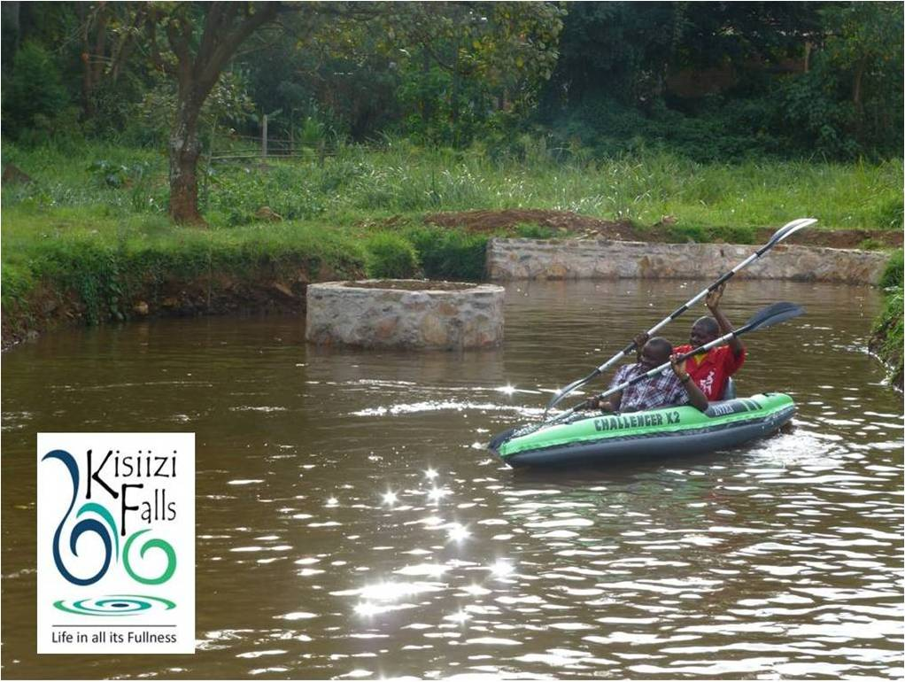
Visit the Hydro-electricity generator, kayak on the small lagoon, enjoy the beautiful birds, view the aquaponics and snack in the Visitors Centre. Stay at Kisiizi Falls Guest House and take home some Kisiizi Falls coffee.

