Life in all its fullness” John 10:10
TRANSFORMATION:
THE EXTRAORDINARY STORY OF THE KISIIZI AHUMUZA CENTRE
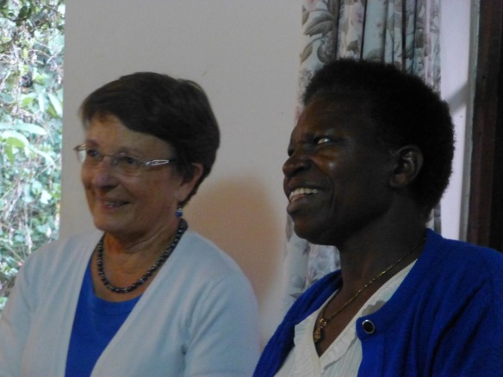
Care for the Vulnerable: Church of Uganda (C.O.U.) Kisiizi Hospital started in 1958 in a disused flax factory in a remote location in Kigezi, south-western Uganda. It has never closed its doors to patients and one of its themes has been “Care for the Vulnerable”. In the late 1990’s a team led by Dr. Lionel Mills, then Medical Superintendent, had preached in the community on St. Luke’s Day about Christians bringing good news to the poor. Afterwards a lady asked them to come and see her son who had been locked up outside for many years as he was mentally confused and out of control. The team took him back to Kisiizi and with compassionate care and prayer he was transformed and again “in his right mind”. This led to recognition that there were many forgotten people in the community with treatable mental illness and the vision to start psychiatric services was born.
Dr. Maureen & Sister Nancy

Partnership: Sister Nancy Mwebesa has been a key figure in the development of the mental health services. A diploma nurse/midwife, she developed a concern and empathy for people with mental illness and so went on to Psychiatric Clinical Officer training. She subsequently ran the Kisiizi service which provided the first ever rural in-patient psychiatry service in Uganda (all the other in-patient beds were located in National or Regional Referral Hospitals but these care for relatively few of the poor from rural areas).
In 2010 Avril Devaney, Director of Nursing at Cheshire & Wirral NHS Partnership NHS Foundation Trust, led a scoping visit to Kisiizi with Linda Shuttleworth, Clinical Psychologist, and Dr. Maureen Wilkinson, Consultant Psychiatrist. Avril’s vision led to the birth of a partnership that has proved enormously valuable with exchange visits to mutual benefit. Kisiizi now provides mental health clinics in the community twice a month, unheard of in rural hard-to-reach areas. Demand is very high with 80 – 120 patients attending each clinic. C.O.U. Kisiizi Hospital subsidises the cost of this outreach so patients are not charged for their consultations. Kisiizi Hospital has liaised closely with the District Health Officer in Rukungiri who has provided some support for medicines for these patients.

From tragedy to blessing – Jamie’s story: In 2011, Avril came back to Uganda with her husband Jim and their four year old son Jamie as part of a team to raise support for mental health work in Kisiizi. Soon after arriving in Uganda Jamie became ill with a serious infection so had to be taken back by ambulance to Kampala and was airlifted to Nairobi where sadly he died ten days later. Jamie’s short life touched so many people in Uganda, Kenya and UK and wonderfully his parents and friends set up Jamie’s Fund in his memory to support mental health work in Kisiizi with a vision to spread this to other parts of Uganda. (See http://jamiesfund.org.uk/ for more details.)
Jamie’s Fund has provided a designated vehicle for Mental Health services and funded the wonderful new Ahumuza Centre to give shelter, love and hope to those with mental illness.
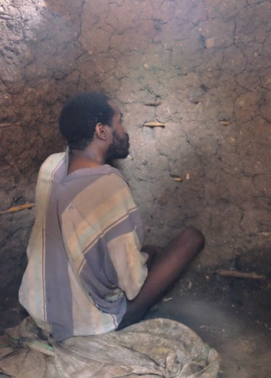
“Ahumuza” means “a place of comfort; He comforts” and encapsulates the goal of compassionate and effective support and care as part of the ministry of Kisiizi Hospital to bring “life in all its fullness”. The Ahumuza Centre incorporates facilities for day patients as well as male and female in-patient wards and facilitates a range of support including occupational therapy. A special area to offer more intensive support to those in a very distressed condition has been included. Outside gardens/recreational areas are being prepared with areas for patients and their relatives to relax and enjoy the beauty of the surrounding hills. Support is still needed to provide kitchen facilities to patients and their families.
Chained up for over 15 years due
to his mental illness
The new Ahumuza Centre to be opened by the Prime Minister on May 19th, 2017.

The Vision: The Ahumuza Centre is also to be a hub of community work and will offer training support to healthcare workers in our region. One key goal is to continue to interact with the communities to reduce stigma of mental illness and to support rehabilitation of patients in their home situations. The existing Mental Health Associations set up by C.O.U. Kisiizi Hospital have proved very successful and it is hoped to develop these further. Representatives are joining the opening celebrations. In addition, traditionally in Uganda epilepsy comes under the remit of Mental Health departments and there are currently very few services available beyond the hospital itself. Kisiizi hopes to develop its community mental health and epilepsy services in partnership with colleagues in C.O.U. Bwindi Hospital and, further afield, C.O.U. Kagando Hospital near Kasese who already have pioneered a community epilepsy programme.

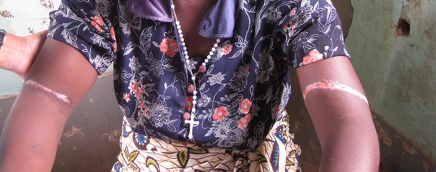
Motivation: Why does C.O.U. Kisiizi Hospital work to provide a service for the mentally ill when it involves subsidising the cost as the patients are often destitute? It is all part of the “care for the vulnerable” theme motivated by Christian love in action, following the example of Christ who said “I have come that they may have life in all its fullness” (John 10:10). This means a goal of health in the full holistic sense: body, mind, spirit, community. Kisiizi Hospital also subsidises neonatal care and rehabilitation services. Even proceeds from the developing Kisiizi Falls tourism project go to the Kisiizi Hospital Good Samaritan Fund that subsidises mental health care, insulin for diabetics, formula milk for mothers of premature babies who have insufficient breast milk and helps to pay costs of health care for the poorest members of the community.
Management and the Board are so grateful to our staff who have provided this service over many years to a very needy community and we rejoice that the new Ahumuza Centre will greatly encourage morale in both patients and Staff. Management also appreciate the patience of the donors when progress has been slow, and the work of the contractors Datek and the consultants Aclaim partnering with Kisiizi in the project.
Scars from being tied up and left to die, while mentally ill
Do come and visit the beautiful Kisiizi Falls and support the Good Samaritan Fund.
More information about Kisiizi is available on www.kisiizihospital.org.ug Thank you so much for your support.

